A study about moving to secondary school
QUESTIONNAIRE FOR TEACHERS

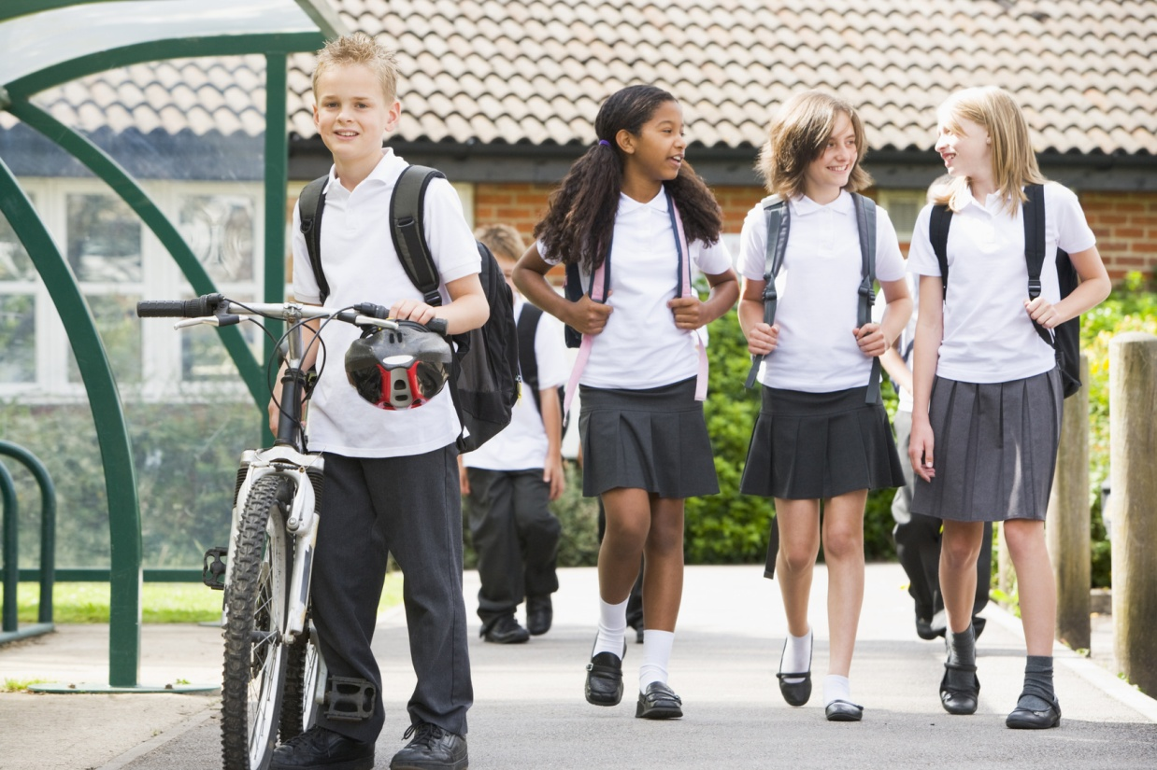

You can also complete this questionnaire online instead at:
www.ucl.ac.uk/stars

Your answers in this questionnaire are confidential. We also won’t share any of your answers with anyone (including the child’s parent) without your prior permission.

To complete the questionnaire:
- Make sure you read each question carefully before you answer.
- Answer the question by ticking the relevant box, or by writing in an answer.
1 | 2 | 3 | 4 | 5
For example:

- Mark only one answer for each question.
- Please try to answer every question.
- Remember that your answers are confidential.
- Once you have completed the questionnaire, please send it back to us in the envelope provided.
We will send you a £5 shopping voucher to thank you for each of these questionnaires you complete.
Thank you for taking the time to be part of this study.

Pupil name
Class
Teacher name

ID number…………………………….(for office use)

Starting Secondary School
Do you expect this child to settle in well at secondary school?
 | Strongly Agree | Agree | Not Sure | Disagree | Strongly Disagree
1. Academically | 1 | 2 | 3 | 4 | 5
2. Socially (with peers) | 1 | 2 | 3 | 4 | 5
3. Socially (with teachers) | 1 | 2 | 3 | 4 | 5
4. To the new routine | 1 | 2 | 3 | 4 | 5

Transition Strategies
Next to each item please indicate whether you used each strategy to prepare this pupil for the transition to secondary school and how helpful you consider that each strategy is/would be in preparing this pupil for the move to secondary school.
 | Did you use this strategy with this pupil? |  |  |  | How helpful do you consider each strategy is/would be in preparing this pupil for the move to secondary school?
 | No | Yes, a little |  | Yes, a lot | Not at all |  | Very little |  | Somewhat | Quite a bit |  | Very much
- Web-based resources | O | 1 |  | 2 | 0 |  | 1 |  | 2 | 3 |  | 4
- Peer support groups with pupils who are going to the same secondary school (e.g. group work on joint projects) | 0 | 1 |  | 2 | 0 |  | 1 |  | 2 | 3 |  | 4
- Drama workshops to develop skills needed for transition | 0 | 1 |  | 2 | 0 |  | 1 |  | 2 | 3 |  | 4
- Teaching secondary school vocabulary (e.g. words such as ‘tutor’) | 0 | 1 |  | 2 | 0 |  | 1 |  | 2 | 3 |  | 4
- Shared projects/bridging units with secondary school (e.g. projects taught before and after the transition) | 0 | 1 |  | 2 | 0 |  | 1 |  | 2 | 3 |  | 4
- Pupil passports (booklets completed by pupils about themselves which are passed on to secondary school) | 0 | 1 |  | 2 | 0 |  | 1 |  | 2 | 3 |  | 4
- Provision of written information about secondary school (e.g. leaflets, maps) | 0 | 1 |  | 2 | 0 |  | 1 |  | 2 | 3 |  | 4
- Meetings with parents to discuss options (e.g. open evenings) | 0 | 1 |  | 2 | 0 |  | 1 |  | 2 | 3 |  | 4
- Parent support groups (informal groups for parents to discuss concerns) | 0 | 1 |  | 2 | 0 |  | 1 |  | 2 | 3 |  | 4
- Additional visits to secondary school (beyond visits organised for whole year group) | 0 | 1 |  | 2 | 0 |  | 1 |  | 2 | 3 |  | 4
Please list any other interventions beyond those used for all year 6 pupils that were put in place for this pupil and not outlined above and indicate how helpful you think each strategy was in preparing this pupil for the move to secondary school.
 |  | How often did you do this? |  |  | How helpful was this strategy in preparing this child for the move to secondary school?
1 …………………………………………………………………………………  …………………………………………………………………………………… |  | A little |  | A lot | Not at all |  | Very little |  | Somewhat | Quite a bit |  | Very much
2 …………………………………………………………………………………  …………………………………………………………………………………… |  | A little |  | A lot | Not at all |  | Very little |  | Somewhat | Quite a bit |  | Very much
Special Educational Needs
Does this child have any special educational needs? |  |  | No |  |  | Yes, School Action |  | Yes, School Action Plus |  |  | Yes, Statement
If yes, please specify type (e.g. Autistic Spectrum Disorder, Behavioural Emotional and Social Difficulties)
………………………………………………………………………………………………………………………………………………………………………………………….
………………………………………………………………………………………………………………………………………………………………………………………….
Transition Support for Pupils with Special Educational Needs
If the child does not have SEN, please move on to the ‘Feelings’ section below
 | Did you use this strategy? |  |  |  | How helpful do you consider each strategy is/would be in preparing pupils for the move to secondary school?
 | No | Yes, a little |  | Yes, a lot | Not at all |  | Very little |  | Somewhat | Quite a bit |  | Very much
- Transition review meeting | O | 1 |  | 2 | 0 |  | 1 |  | 2 | 3 |  | 4
- Sharing written information with secondary teachers on pupil’s needs (e.g. information about support at primary) | O | 1 |  | 2 | 0 |  | 1 |  | 2 | 3 |  | 4
- Liaison between primary staff and secondary SENCO (e.g. meetings, emails, telephone calls) | O | 1 |  | 2 | 0 |  | 1 |  | 2 | 3 |  | 4
- Training regarding pupil’s needs provided by primary teachers to secondary staff (e.g. opportunities for secondary staff to observe pupil at primary) | O | 1 |  | 2 | 0 |  | 1 |  | 2 | 3 |  | 4
- External agency support to address transition issues (e.g. support regarding travel arrangements) | O | 1 |  | 2 | 0 |  | 1 |  | 2 | 3 |  | 4

***Please turn over for the final section***

Behaviour
For each item, please mark the box for Not True, Somewhat True or Certainly True. It would help us if you answered all items as best you can, even if you are not absolutely certain. Please give your answers on the basis of the child's behaviour over the last six months or this school year.
 |  | Not True |  |  | Somewhat True |  |  | Certainly True
- Considerate of other people’s feelings |  | 0 |  |  | 1 |  |  | 2
- Restless, overactive, cannot stay still for long |  | 0 |  |  | 1 |  |  | 2
- Often complains of headaches, stomach-aches or sickness |  | 0 |  |  | 1 |  |  | 2
- Shares readily with other children (treats, toys, pencils, etc.) |  | 0 |  |  | 1 |  |  | 2
- Often has temper tantrums |  | 0 |  |  | 1 |  |  | 2
- Rather solitary, tends to play alone |  | 0 |  |  | 1 |  |  | 2
- Generally obedient, usually does what adults request |  | 0 |  |  | 1 |  |  | 2
- Many worries, often seems worried |  | 0 |  |  | 1 |  |  | 2
- Helpful if someone is hurt, upset or feeling ill |  | 0 |  |  | 1 |  |  | 2
- Constantly fidgeting or squirming |  | 0 |  |  | 1 |  |  | 2
- Has at least one good friend |  | 0 |  |  | 1 |  |  | 2
- Often fights with other children or bullies them |  | 0 |  |  | 1 |  |  | 2
- Often unhappy, down hearted or tearful |  | 0 |  |  | 1 |  |  | 2
- Generally liked by other children |  | 0 |  |  | 1 |  |  | 2
- Easily distracted, concentration wanders |  | 0 |  |  | 1 |  |  | 2
- Nervous or clingy in new situations, easily loses confidence |  | 0 |  |  | 1 |  |  | 2
- Kind to younger children |  | 0 |  |  | 1 |  |  | 2
- Often lies or cheats |  | 0 |  |  | 1 |  |  | 2
- Picked on or bullied by other children |  | 0 |  |  | 1 |  |  | 2
- Often volunteers to help others (parents, teachers, other children) |  | 0 |  |  | 1 |  |  | 2
- Thinks things out before acting |  | 0 |  |  | 1 |  |  | 2
- Steals from home, school or elsewhere |  | 0 |  |  | 1 |  |  | 2
- Gets on better with adults than with other children |  | 0 |  |  | 1 |  |  | 2
- Many fears, easily scared |  | 0 |  |  | 1 |  |  | 2
- Sees tasks through to the end, good attention span |  | 0 |  |  | 1 |  |  | 2
- Overall, do you think that this child has difficulties in one or more of the following areas: emotions, concentration, behaviour or being able to get on with other people? |  | No |  | Yes –  minor difficulties |  |  | Yes –  definite difficulties |  |  | Yes –  severe difficulties
If you have answered “Yes”, please answer the following questions about these difficulties:
- Do the difficulties upset or distress the child? | Not at all |  | Only a little |  |  | Quite a lot |  |  | A great deal
Do the difficulties interfere with the child’s everyday life in the following areas:
- Peer relationships | Not at all |  | Only a little |  |  | Quite a lot |  |  | A great deal
- Classroom learning | Not at all |  | Only a little |  |  | Quite a lot |  |  | A great deal
- Do the difficulties put a burden on you or the class as a whole? | Not at all |  | Only a little |  |  | Quite a lot |  |  | A great deal
Thank you for completing this questionnaire.

